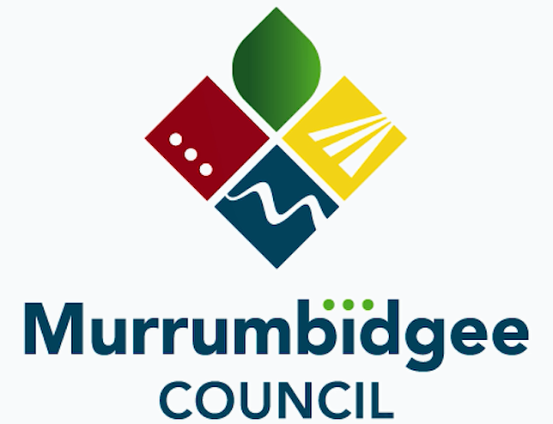

POSITION DESCRIPTION

Position Title: |  | Senior Technical Officer – Contracts
Business Unit: | Infrastructure |  | Classification/Grade:
Position No: | MC |  | Reports to: MC | Director Infrastructure
Location: | Coleambally, Darlington Point,  Jerilderie |  | Positions reporting directly to this position: | Surveillance Officer

Primary Purpose of the Position

This position exists to provide a high-quality level of contract administration for road projects and associated civil works routine work funded through the Road Maintenance Council Contract (RMCC) with the Transport for NSW (TfNSW) of NSW and subcontractors.

This position contributes to the organisation's goals by providing administrative support to the infrastructure section to ensure that the necessary contract operations and services are carried out efficiently and effectively. Other duties will be associated with providing administrative support for various engineering projects.

Roles & Responsibilities

The Senior Technical Officer is directly responsible for the following roles and responsibilities:

- Undertake administration work for RMCC Capital Works Program in accordance with the contract and maintain all contract-related documentation.
- Assist with works proposals (quotes) for ordered works under RMCC and other Projects.
- Check the progress of works, claims, and incoming invoices of the contracts in association with the Manager – Infrastructure and Finance.
- Prepare submissions and monthly progress claims/certificates for works under the RMCC contract for final approval.
- Prepare payment claims with quality agreements to TfNSW for routine and individual priced works for approval.
- Administer the RMCC renewal, extension, and variations in association with the Manager and /or Executive Leader.
- Liaise with the TfNSW’s Contract Manager and TfNSW Surveillance Officer.
- Manage correspondence between Council and TfNSW under RMCC for Manager - Infrastructure.
- Prepare and administer period contracts for civil works (casual plant, bitumen sealing, concrete supply, etc).
- Maintain Reflect for all TfNSW accomplishments; ensuring it is updated on a regular basis.
- Assistance with RMAP for Routine Maintenance and construction to forecast Council’s works program to predict variations in program and funding required.
- Engaging consultants to assist in pre-planning works (environmental, geotechnical, designers, utility providers, etc.).
- Liaising with regulatory bodies to ensure all permits/licenses are in place.
- Preparation of traffic management plans, site safety plans, site environmental plans, and quality management plans.
- Carry out inspections of works under the control of Councils’ operations department and ensure quality assurance during construction.
- Assist with routine work associated with database, records, and asset management maintenance.
- Records and Finance
- Completion of accurate timesheets with job numbers, daily plant checklists, daily running sheets, and other work-related documentation.
- Ensure compliance with Council’s record management systems.
- Ensure that all critical processes and procedures are documented, including standard operating manuals.
- Seeks approval from Manager for expenses/claims, as required by Council’s policies and guidelines.
- IP&R and Strategic Planning
- Contribution towards the goals outlined in Council’s Delivery and Operational Plan and any other appropriate planning/reporting frameworks that apply to the scope of the position.
- WHS and Environment
- Ensure all work is completed using safe work practices following safe work method statements, risk assessments, injury and incident reporting, and other WHS requirements for own area of work.
- Documented SWMS, risk assessments, and other risk management documents developed and implemented. All accidents, incidents, and near misses are reported within the correct timeframe.
- To review & participate in environmental incident investigation and nominated corrective measures including the observation and reporting of any new environmental aspects and impacts.
- Oversee contractor compliance with all WH&S and environmental programs and procedures on projects and maintenance within position scope.

Obligations
- Display a positive image while meeting customer service standards for all Council stakeholders both internal and external relevant to the role. Act with Integrity; be ethical and professional and adhere to Murrumbidgee Council’s Values of Trust, Honesty, Teamwork, and Respect.
- Conduct all duties in accordance with relevant Quality Assurance, WHS & Environmental Management procedures for all work activities.
- All employees have a legal obligation to comply with statutory and Council’s WH&S Management System, WH&S policies, procedures, and work instructions.
- Where applicable comply with Council Delegation levels.
- Conduct all duties in accordance with Council’s Code of conduct, plans policies, and procedures.
- Maintain physical capability to undertake duties appropriate to the role

Authority and accountability:
- Provides a professional advisory role to people within or outside the employer. Such advice may commit the employer and have a significant impact on external parties dealing with the employer. The position may manage several major projects or sections within a department of the employer.
Judgement and problem solving:
- Positions have a high level of independence in solving problems and using judgement. Problems can be multi-faceted requiring detailed analysis of available options to solve operational, technical, or service problems.
Specialist knowledge and skills:
- The skills and knowledge to resolve problems where a number of complex alternatives need to be addressed.
Management skills:
- May be required to manage staff, resolve operational problems and participate in a management team to resolve key problems.
Interpersonal skills:
- Interpersonal skills in leading and motivating staff may be required. Persuasive skills are used in seeking agreement and discussing issues to resolve problems with people at all levels. Communication skills are required to enable the provision of key advice both within and outside the employer and to liaise with external bodies.
Qualifications and experience:
- Tertiary qualifications combined with a high level of practical experience and in-depth knowledge of work

Essential Qualifications and experience:

- Tertiary Qualifications (Diploma or recent Degree Graduate) in Civil Engineering, Civil Construction, or equivalent experience with TfNSW / RMCC (Road Maintenance Council Contract), demonstrated experience in a similar role (3+ years).
- Sound literacy, numeracy, and computer skills in order to complete required documentation and use relevant technical software.
- Sound knowledge of Contract Administration and/or Civil Engineering Construction preferably applicable to the local government context, with the demonstrated ability to effectively apply this knowledge.
- Possess and maintains a current class ‘C’ Drivers licence
- New South Wales Construction Induction Certificate (White Card);
- New South Wales Traffic Management Certification in Prepare a Work Zone Traffic Management Plan
- Demonstrated understanding of and commitment to the principles and legislative requirements of Work Health and Safety (WH&S).
- Manual Handling Training
- Ability to perform manual tasks with dexterity, including general construction, machine operation, and fit to undertake the duties outlined in this position description, safely.
- Australian resident or equivalent or holding a Visa allowing employment in Australia.
Desirable:
- Local Government experience.
- Knowledge of the legislative requirements pertaining to the engineering field in Local Government, in particular, the Local Government Act 1993, Roads Act 1993 and Environmental Planning and Assessment Act 1979 and the NSW Integrated Planning and Reporting Framework;
- Membership of a professional association (ie IMEA, IPWEA, Engineers Australia etc)

Authorisation:

Prepared By: | DI/P&C | Date Issued: | August 2021
Current Incumbent |  | Date Commenced:
Manager:

Reviewed By: |  | Date:

This position description is subject to change from time to time as Council’s organisation may be developed or restructured. Any such reorganisation of duties shall be the subject of discussion with the position incumbent.

